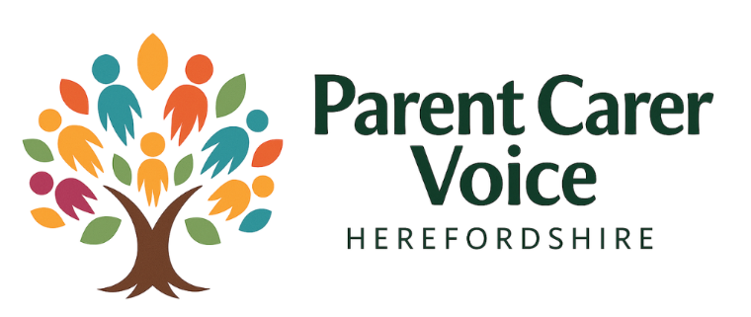

Safeguarding Policy
  - Version: 3.0
  - Review Date: September 2026

Introduction
This Safeguarding Policy sets out our commitment to protecting children, young people, and vulnerable adults. It incorporates statutory guidance, best practice standards, and digital safeguarding measures to ensure compliance and safety.

Legal and Statutory Framework
This policy aligns with the following statutory guidance and legislation:
- Working Together to Safeguard Children (2023)
- Keeping Children Safe in Education (2025)
- Crime & Policing Bill (2025) – Mandatory Reporting
- Data Protection Act 2018 and UK GDPR
- Children’s Wellbeing & Schools Bill (2025)

Roles and Responsibilities
Designated Safeguarding Lead (DSL): Oversees safeguarding strategy, referrals, and compliance.
Deputy DSL: Supports DSL and manages day-to-day safeguarding concerns.
All Staff: Responsible for identifying and reporting concerns promptly.
Board/Trustees: Ensure policy implementation and annual review.

Reporting and Escalation Process
1. Immediate risk: Contact emergency services (999).
2. Report concerns DSL or Deputy DSL without delay.
3. DSL logs concern and decides next steps (Early Help, referral to MASH).
4. Maintain confidentiality and accurate records.
5. Escalate unresolved concerns to Local Safeguarding Partnership.

Digital Safeguarding
We implement measures to protect individuals during online activities:
- Risk assessments for social media and live-streamed events.
- Moderation protocols and incident reporting.
- Staff training on online safety and acceptable use.
- GDPR compliance for digital data handling.

GDPR and Data Protection
Safeguarding records are processed lawfully under UK GDPR:
- Secure storage and restricted access.
- Retention schedules per statutory guidance.
- Privacy notices for children and families.
- Procedures for data breaches and subject access requests.

Policy Review and Compliance
This policy will be reviewed annually or sooner if statutory changes occur. Version history and staff acknowledgements will be maintained. Compliance audits will be conducted regularly.

Quick Reference Table
Key Area | Summary
Legal Framework | Working Together 2023, KCSiE 2025, GDPR
Roles | DSL, Deputy DSL, All Staff, Trustees
Digital Safety | Risk assessments, moderation, training
Reporting | Immediate risk → DSL → MASH referral
Data Protection | Secure storage, retention, breach response
Review | Annual review, version control, compliance checks

