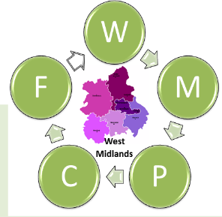
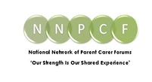

NNPCF Membership Policy

Introduction
This policy sets out the principles and procedures for membership of the National Network of Parent Carer Forums (NNPCF). It ensures compliance with relevant legislation and guidance, and supports transparency, inclusivity, and accountability.

Membership Criteria
Full membership is open to local Parent Carer Forums that meet the following requirements:
- Be constituted and operate within the principles of co-production.
- Represent the views of parent carers in their local area.
- Comply with safeguarding and data protection requirements.

Associate Membership
Associate membership may be granted to organisations or individuals who support the aims of the NNPCF but do not meet the criteria for full membership. Associate members have no voting rights.

Complaints and Disciplinary Process
Complaints regarding membership will be handled in accordance with the NNPCF Complaints Policy. Disciplinary action may include suspension or termination of membership where there is a breach of this policy or associated governance requirements.

Legal References
This policy is governed by and complies with the following legislation and guidance:
- Companies Act 2006, as amended by the Economic Crime and Corporate Transparency Act 2023, including:
- Identity verification requirements for directors and persons with significant control (effective November 2025).
- Restrictions on corporate directors and enhanced transparency measures.
- Updated registered office requirements (physical address mandatory).
- Removal of certain statutory registers (effective November 2025).
- Employment Law (current and forthcoming changes under the Employment Rights Bill), including:
- Day-one rights for unfair dismissal and parental leave.
- Restrictions on zero-hours contracts and fire-and-rehire practices.
- Enhanced anti-harassment duties and limitations on NDAs.
- Statutory Sick Pay reforms (effective April 2026).
- Charity Commission Guidance for governance and trustee responsibilities.
- UK GDPR and Data Protection Act 2018 for handling member data.
- Safeguarding Policies applicable to vulnerable groups.

